GAS LEAKAGE MONITORING AND ALERTING SYSTEM

PROJECT DESIGN PHASE-I

SOLUTION ARCHIECTURE

**PROBLEM STATEMENT**

Gas leakage leads to various accidents resulting into both financial loss as well as human injuries. In humans daily life, environment gives the most significant impact to their health issues like the risk of fires, explosion, suffocation,etc,..Gas leakage can also cause fire that will lead to serious injury or death and it also can destroy human properties. The leakage of gases only can be detected by human nearby and if there are no human nearby, it cannot be detected. But sometimes it cannot be detected also by human that has a low sense of smell. . This system was developed by using IoT to give real-time response to the user and the nearest fire station. Thus, this system will help to detect the presence of gas leakage.



**SOLUTION ARCHITECTURE:**

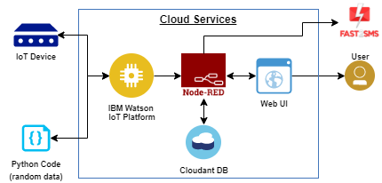

The system can be taken as a small attempt in connecting the existing primary gas

detection methods to a mobile platform integrated with IoT platforms. The gases are sensed in an area of 1m radius of the rover and the sensor output datas are

continuously transferred to the local server. The accuracy of MQ sensors are not upto the mark thus stray gases are also detected which creates an amount of error in the outputs of the sensors, especially in case of methane. Further the availability and storage of toxic gases like hydrogen sulphide also creates problems for testing the assembled hardware. As the system operates outside the pipeline, the complication of system maintenance and material selection of the system in case of corrosive gases is reduced. Thus the system at this stage can only be used as a primary indicator of leakage inside a plant.